Reservoir Molds

|  |
| --- |
| **C:\Users\Actif\Documents\0 Ethiopie\8.Capi\Tank Sizing\Individual\Building\Wall2.jpg** |
|  |

**Materials needed:**

Metal sheet (2 mm x 2m x 1 m) = 15 pieces

Flat iron bar (8 mm x 50 mm x 6m) = 25 pieces

**Explanation:**

Inside 2 rows of 100cm height + 1 row of 80 cm height = total height of 280cm

Outside 3 rows of 100 cm height = total height of 300cm (20 cm difference due to 10 cm of bottom slab and 10 cm of top slap)

|  |  |
| --- | --- |
|  |  |
|  | |

# Outside (high 100 cm): 3 rows = 12 pieces

|  |  |
| --- | --- |
| C:\Users\Actif\Documents\0 Ethiopie\8.Capi\Tank Sizing\Tank Opti\Images\Outside Short.jpg |  |

# Inside High (high 100 cm): 2 rows = 2 pieces of each type

# + Inside low (high 80 cm): 1 rows = 1 pieces of each type

|  |  |
| --- | --- |
| C:\Users\Actif\Documents\0 Ethiopie\8.Capi\Tank Sizing\Tank Opti\Images\Inside N.jpg | |
| C:\Users\Actif\Documents\0 Ethiopie\8.Capi\Tank Sizing\Tank Opti\Images\Inside half.jpg |  |
| C:\Users\Actif\Documents\0 Ethiopie\8.Capi\Tank Sizing\Tank Opti\Images\Inside Door.jpg |  |

# Details

1. Door Handles

Add 4 angle Bar 15 cm long on each corner of the door to facilitate door removal. Be careful not to place this handles too close to the holes.

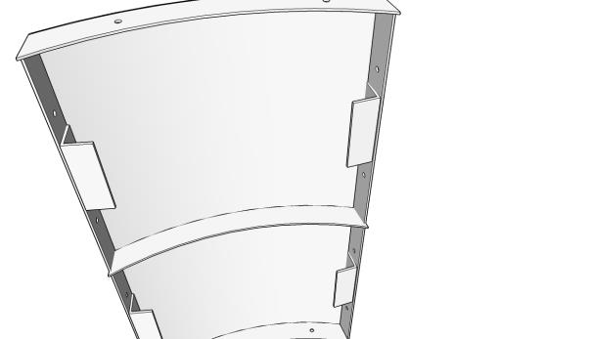

1. Thorough grinding and polishing of around doors

For the inside ring : can you ask them to grind very smoothly the door side as well as the part of the inside ring in contact with the door (All angled bars : 2 sides of the door + 2 sides of the inside mold). No need to paint this part we will oil it each time we use it.

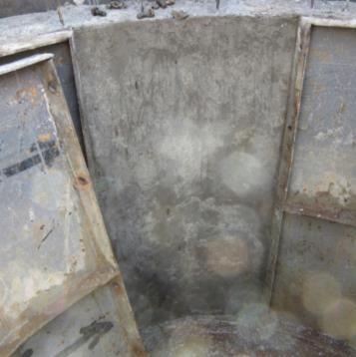

1. Use of Drilling Template:

Can you ask them to use a drilling template so that each hole is always at the same place and each piece can be used at any place?

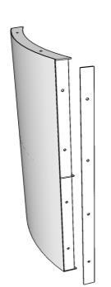A drilling template is an additional piece of flat iron (A) that is the same as the real piece (B) :

1. First the template (A) is drilled at the right place
2. The template is attached to the piece to be drilled (B)
3. The B piece is drilled through the hole of the template (A)

**(B)**

**(A)**